

IATEFL International Conference and Exhibition
16 -19 April 2024 at the Brighton Centre

Accommodation

VisitBrighton’s Conference Delegate Accommodation Bureau will be happy to arrange accommodation for you during your stay in the city for the IATEFL International Conference and Exhibition.

On receiving your request for accommodation we shall process a booking and send you a reservation form indicating your accommodation details. Please note that reservation forms will be emailed where possible. Payment is then made direct to the establishment in accordance with their terms and conditions. We require a credit card number to guarantee your reservation. For group bookings we can arrange for the hotel to send an invoice for pre-payment.

Bookings can also be made online at: https://book.passkey.com/go/ iatefl2024. The online system gives full details on the accommodation available.

Completed bookings forms can be emailed to: delegates@visitbrighton.com. If you require any assistance or information do get in touch via this email or by calling 01273 292626.

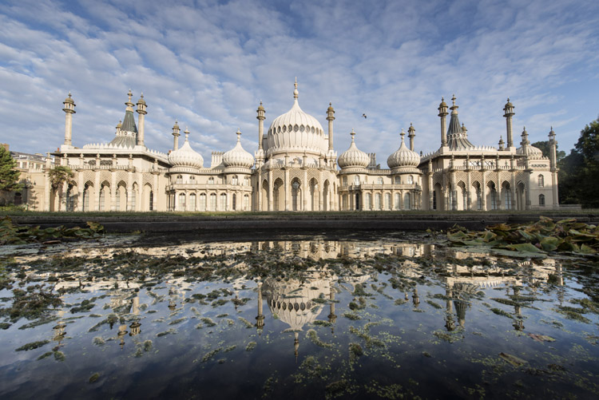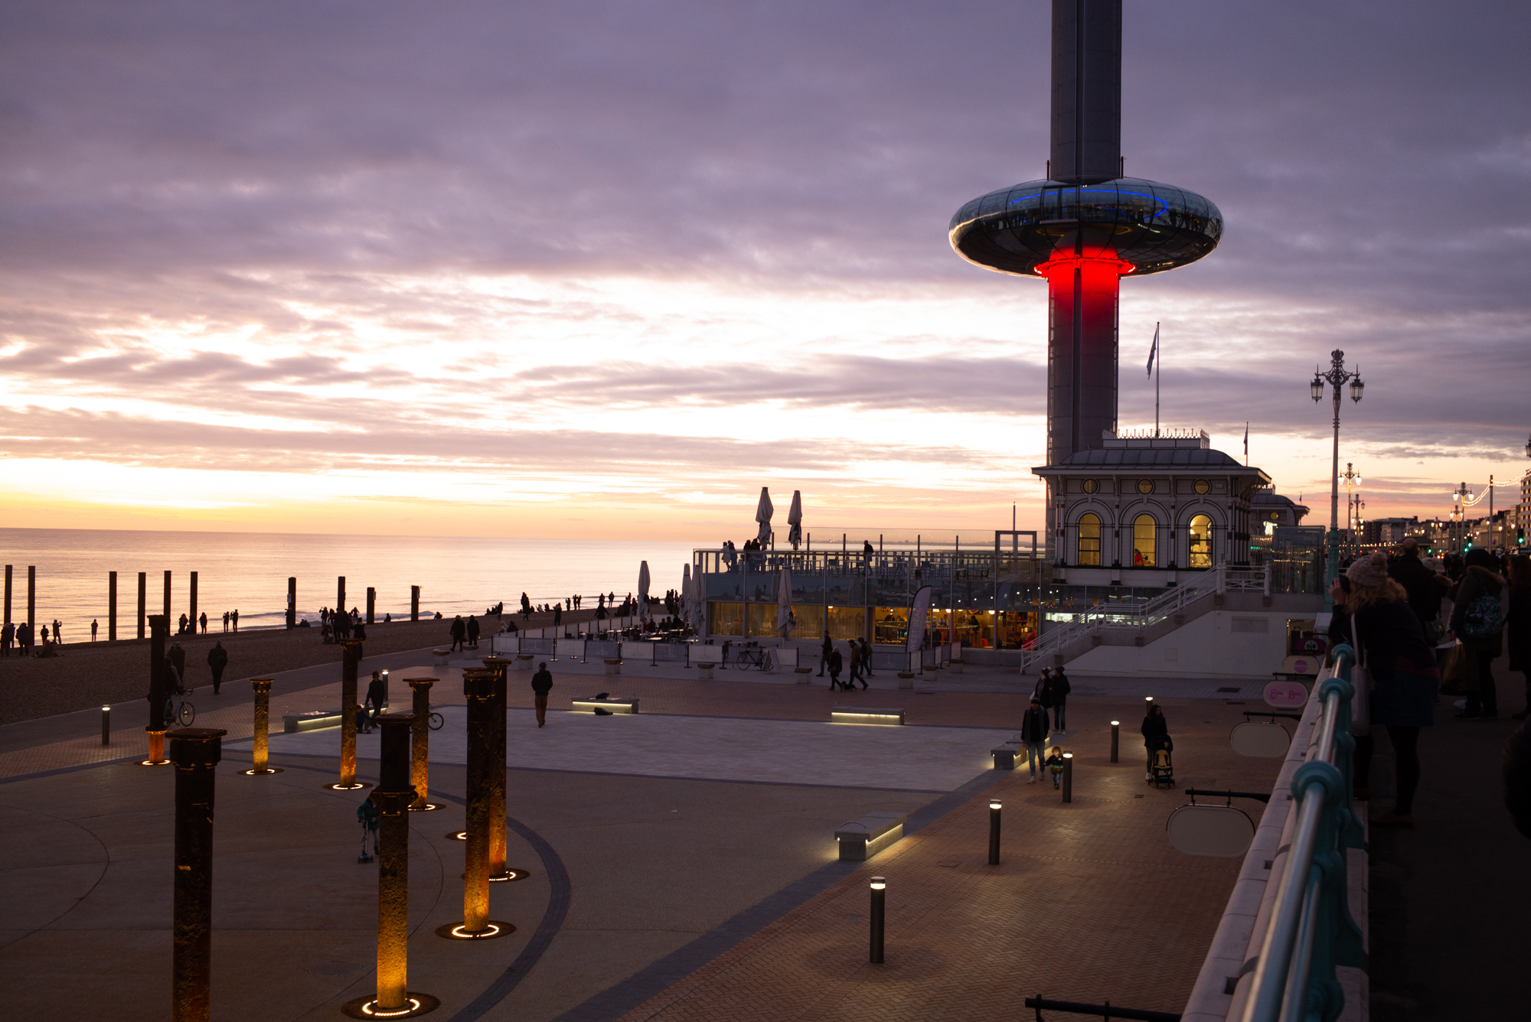

IATEFL International Conference and Exhibition
16-19 April 2024 at the Brighton Centre

Accommodation Booking Form

Full details of the accommodation available and bookings can also be made at https://book.passkey.com/go/iatefl2024 . If processing your booking on-line you will receive an email confirmation on completion of your reservation.

PLEASE COMPLETE YOUR DETAILS IN BLOCK CAPITALS

TITLE
FIRST NAME
SURNAME
ADDRESS
TOWN
COUNTY
POSTCODE
CONTACT NUMBER
EMAIL

Accommodation Requirements:

Arrival Date |  |  | Departure Date
No. of people
Occupancy Type  No. of Rooms | Single ◻ Double □ Twin □ Family □
Please indicate your maximum price per person per night
Special Requirements

A reservation form will be emailed to you (or posted if no email address given). Full payment must go direct to the accommodation provider in line with their terms and conditions – please check your confirmation for details.

Card Number
Name on card
Start date |  | Expiry date
3 digit security no

◻Please tick here if you do not wish to be contacted by us from time to time with latest news and special offers in the city
◻ By completing this booking form I acknowledge that I have read and accepted VisitBrighton’s privacy policy. Your details will be used for the purpose of this booking only.
Our policy can be viewed at https://www.visitbrighton.com/information/data-protection-policy

